**EXP NO 6:**Create a simple cloud software application for Hospital information system for SIMATS Hospital using any Cloud Service Provider to demonstrate SaaS with fields of patient name, age, address, phone, email, Attender name, attender phone, doctor name, diseases, etc

**AIM:**

TO create a simple cloud software application for Hospital information system using any cloud service provider to demonstrate saas.

**PROCEDURE:**

**STEP1:** GOTO ZOHO.COM STEP

**STEP2:** LOGIN TO THE ZOHO.COM STEP

**STEP 3**: SELECT ONE APPLICATION STEP

**STEP 4:** ENTER APPLICATION NAME STEP

**STEP 5:** CREATED NEW APPLICATION STEP

**STEP 6:** SELECT ONE FORM STEP

**STEP 7:** THE SOFTWARE HASE BEEN CREATED

**STEP 1** GO TO ZOHO.COM

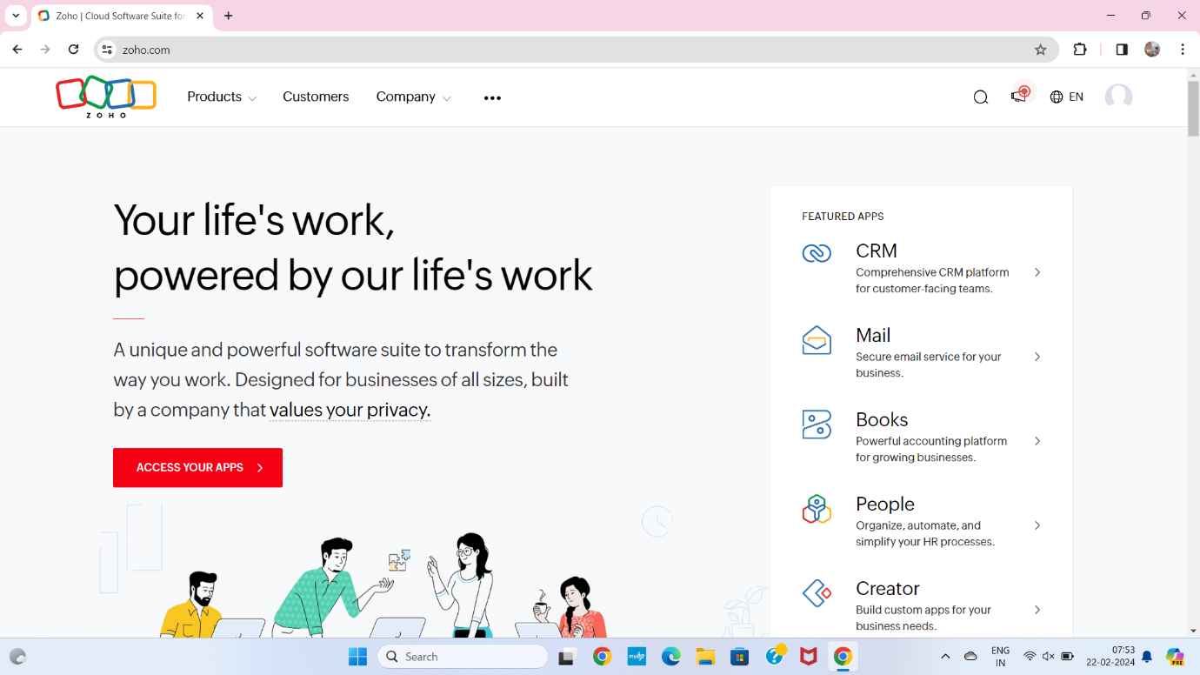

**STEP2** LOGIN TO THE ZOHO.COM

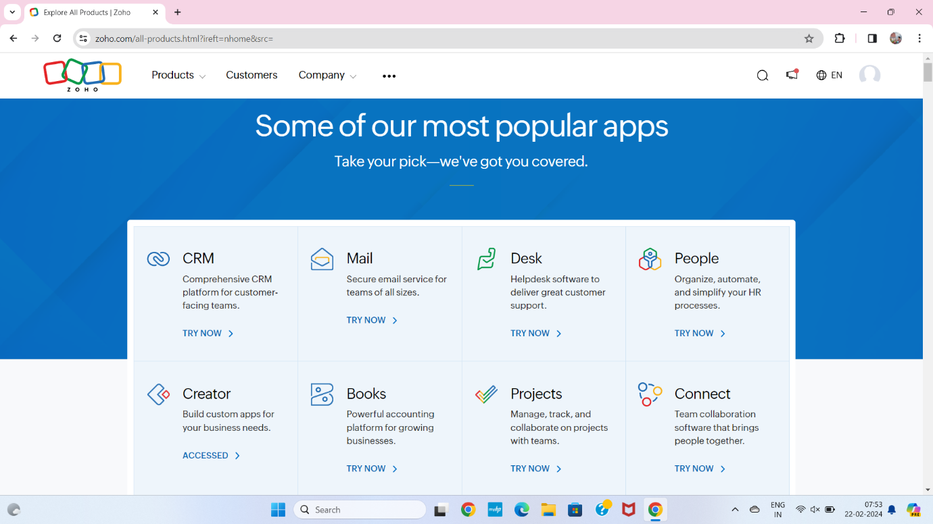

**STEP 3** SELECT A CREATE FROM SCRATCH

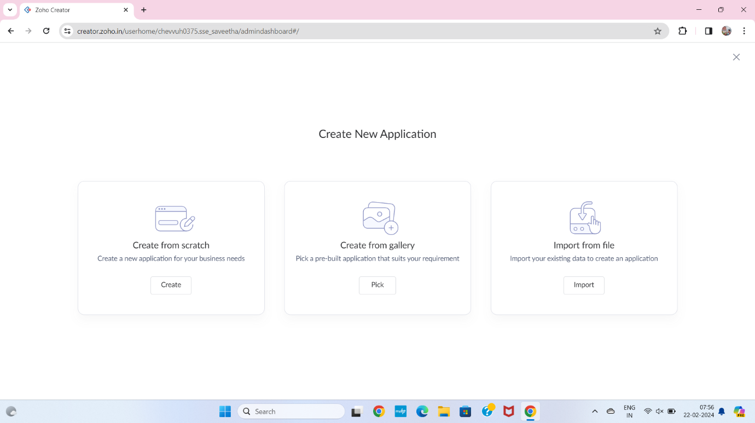

**STEP 4** SELECT APPLICATION NAME AS HOSPITAL INFORMATION SYSTEM

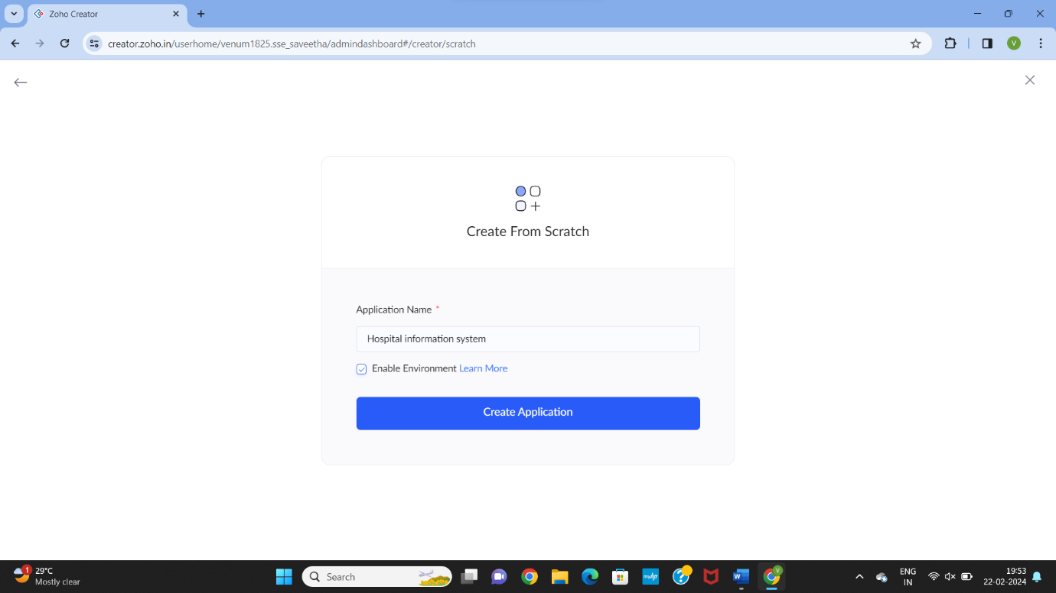

**STEP 5** CREATE A NEW FORM

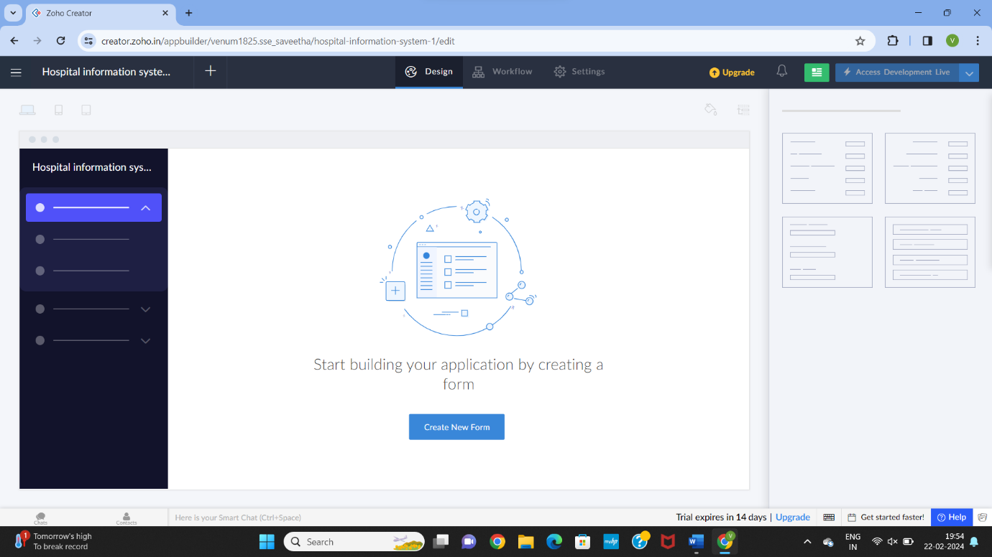

**STEP 6** SELECT BASIC FIELD FROM GIVEN BELOW AND DEVELOP APPLICATION

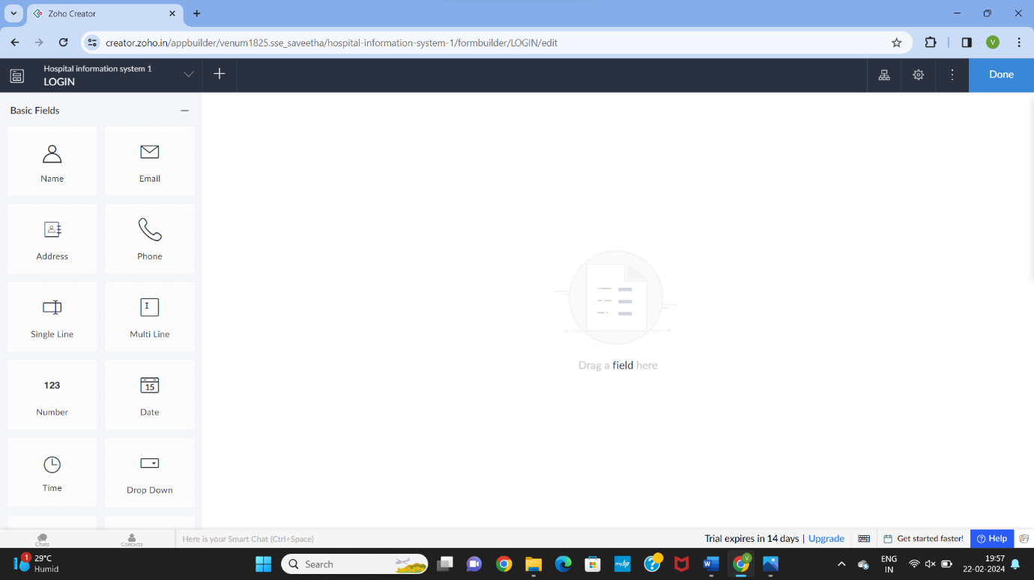

**STEP 7** THE SOFTWARE HASE BEEN CREATED SLOT BOOKING

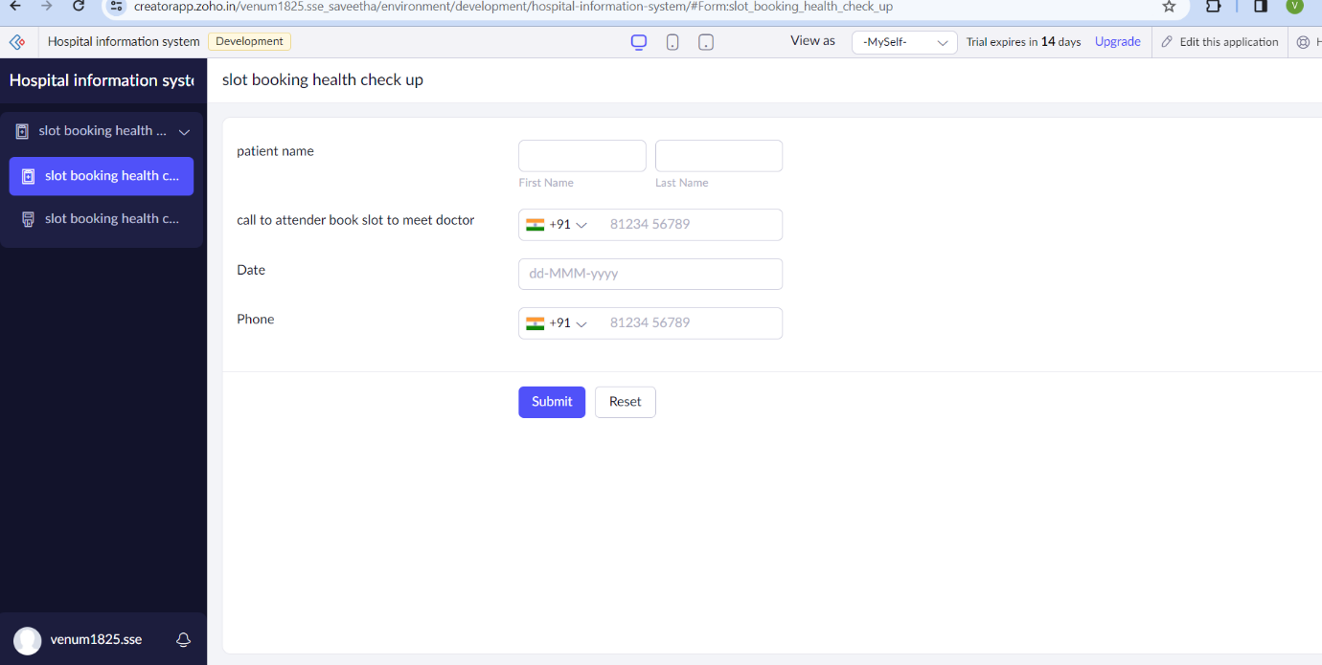

**STEP 8** THE SOFTWARE HASE BEEN CREATED ATTENDER OR RECEPTIONIST

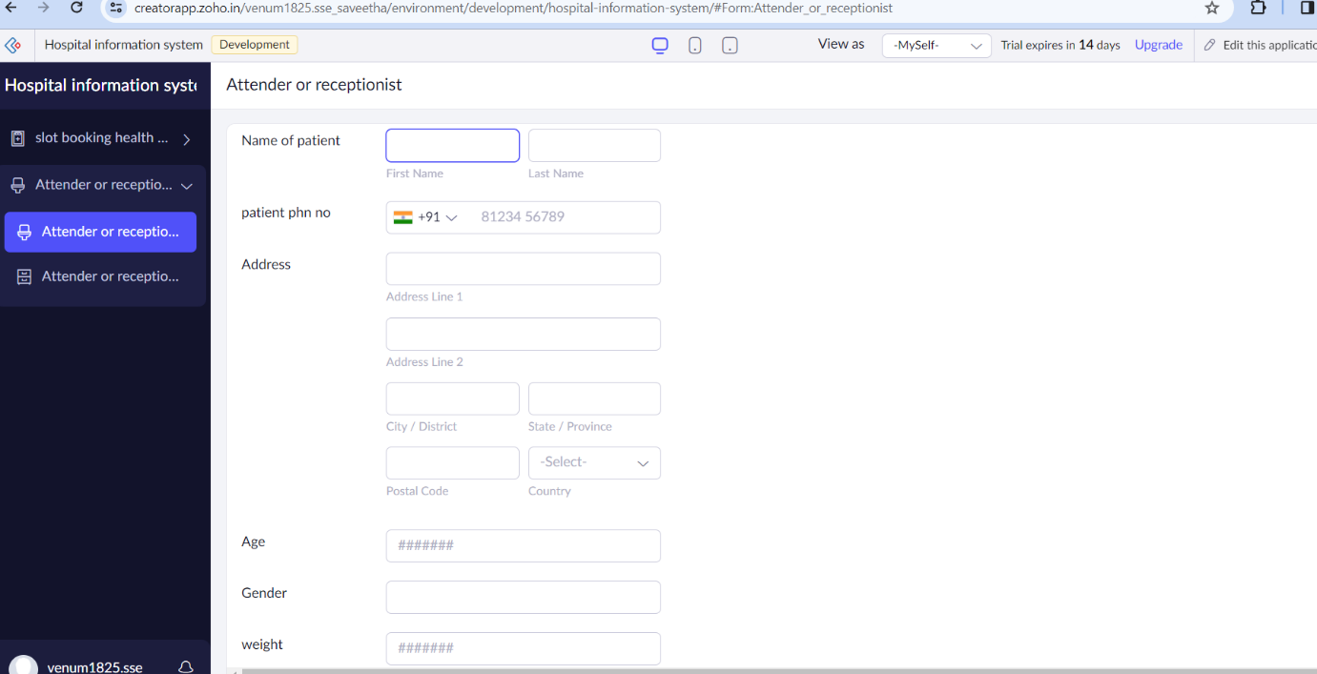

**STEP 9** THE SOFTWARE HASE BEEN CREATED OP FEE

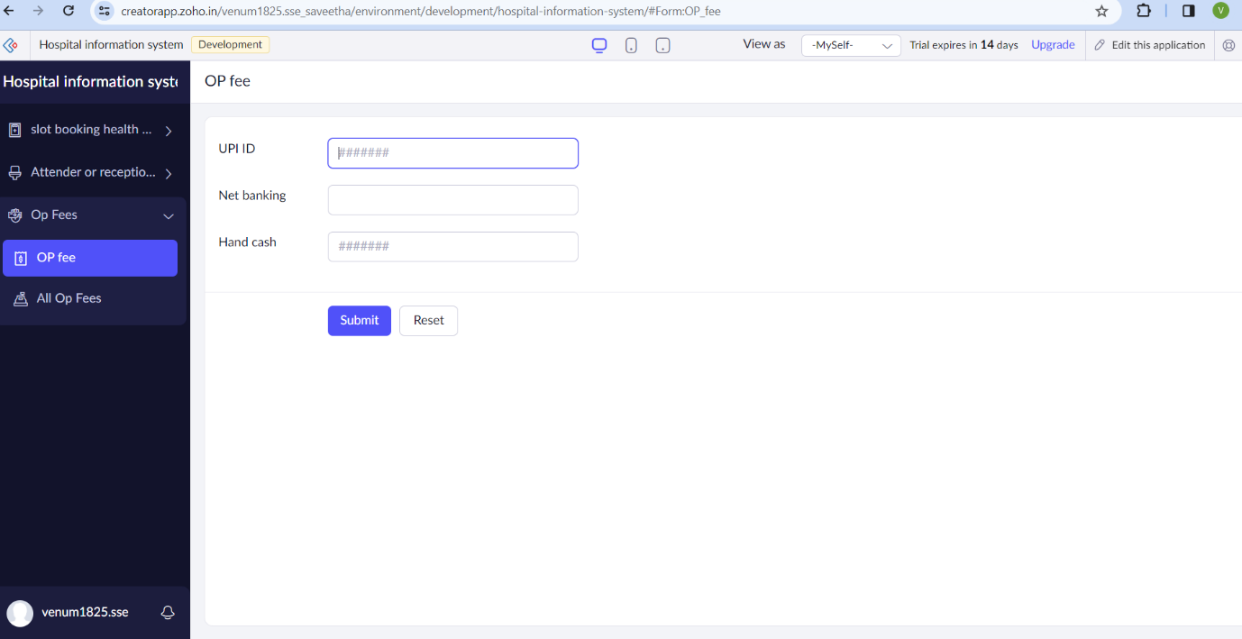

**STEP 10** THE SOFTWARE HASE BEEN CREATED DOCTOR

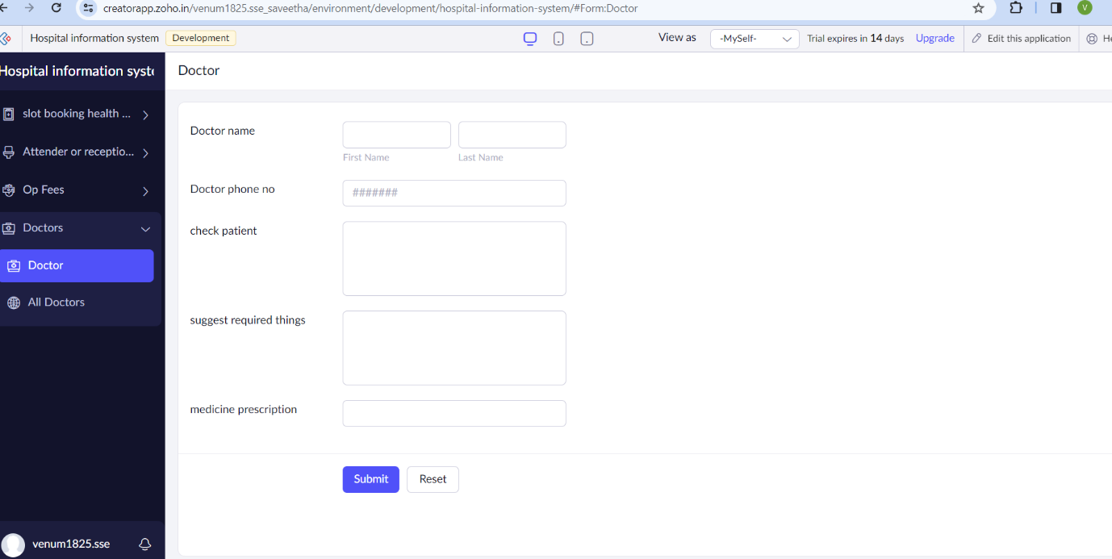

**STEP 10** THE SOFTWARE HASE BEEN CREATED DOCTOR

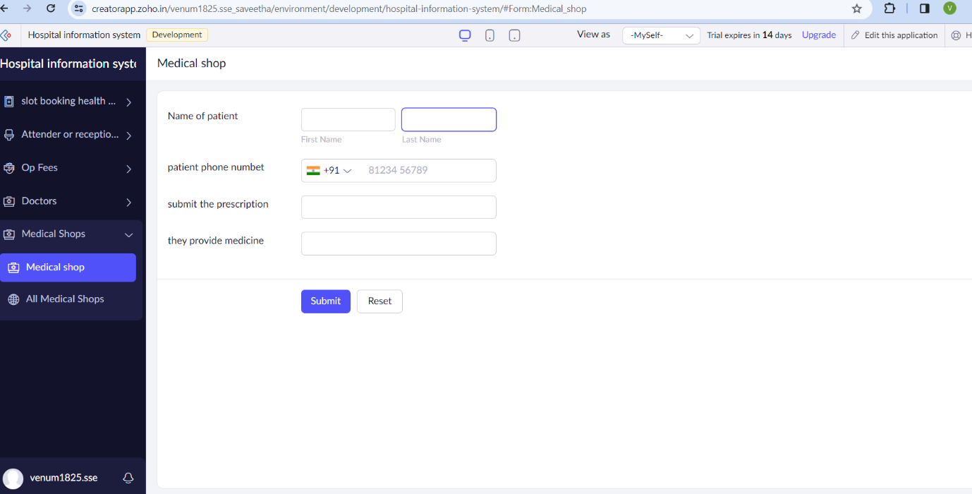

**STEP 11** THE SOFTWARE HASE BEEN CREATED PAYMENT IN MEDICAL SHOP

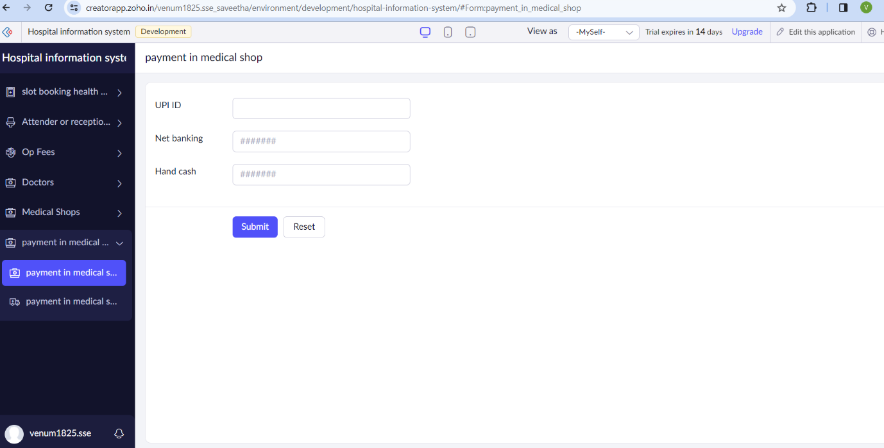

**STEP 12** THE SOFTWARE HASE BEEN CREATED

